Vipassana User Guide.

|  |  |
| --- | --- |
| ITEM | Page |
| Introduction | 2 |
| Create a lecturer | 3 |
| Create a seminar | 4 |
| Using the Save Button | 6 |
| Using the Close Button | 7 |
| Using the Clear All Button | 8 |
| Search Seminar | 9 |
| Search Lecturer | 10 |

**Introduction**

When first opening the „Vipasanna” system, this window will pop-up.

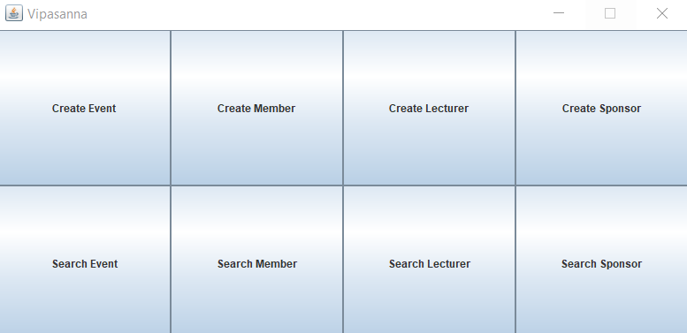

From here, you can select one of the 8 options:

-the first row gives you the option to create an event/member/lecturer/sponsor

-the second row gives you the option to search for an event/member/lecturer/sponsor

**Create a Lecturer**

To Create a Lecturer, you will have to click the „Create Lecturer” button

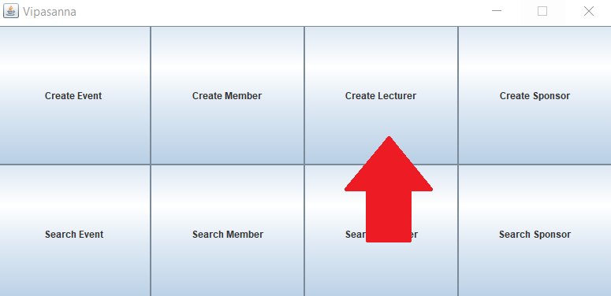

After clicking the button, a new window will pop-up

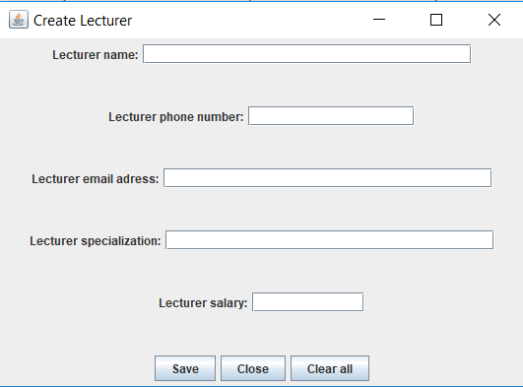

In the new window, you can click each individual field and enter the data for the lecturer.

If you wish to have no salary for the created lecturer, leave the field empty.

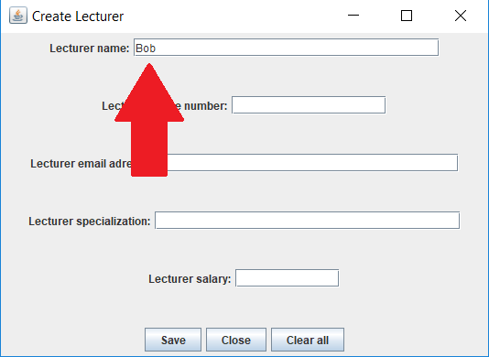

**Create a Seminar**

To create a Seminar, you will first have to click the „Create Event” button.

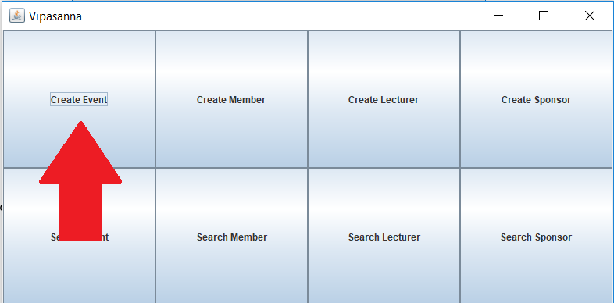

After you click the „Create Event” button, a new window will pop-up, and you will have to click the „Seminar” button.

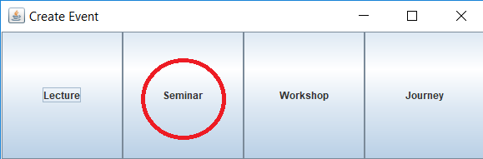

A new window will appear, in which you will have to enter all the details of the seminar.

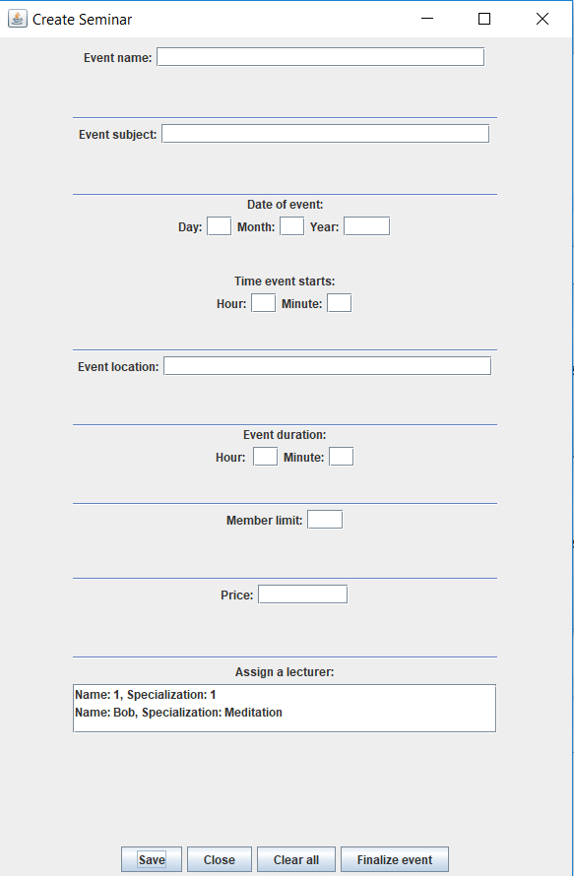

There are some rules when creating an event.

1)You cannot create an event without assigning a lecturer, if done so, the system will display the following error:

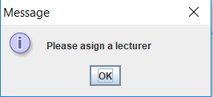

2)You need to input the correct type of data, for example, in the date and hour fields, you can only enter digits, if you make an error, the system will display the following error:

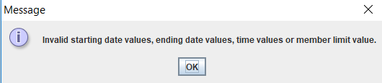

**Using the Save Buton**

After you are done inputing all the data, click the Save button, which wil close the window and will save all the inserted data.

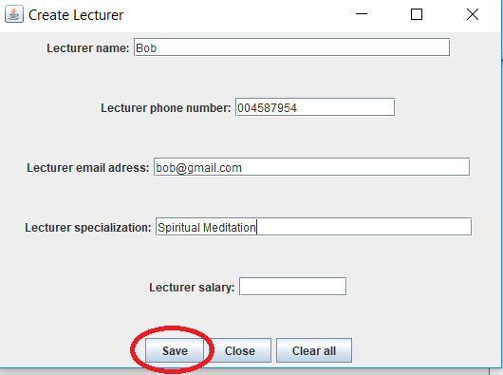

**Using the Close button**

If, at any point of using the system, you wish to close a window, you can do so by pressing the „Close” button on the bottom side of the window.

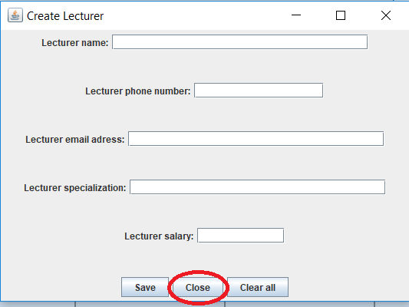

**Using the Clear All button**

If, you realize that some of the data you entered is incorrect, you can use the „Clear all” button on the bottom side of the window, which will empty all the fields to input new information.

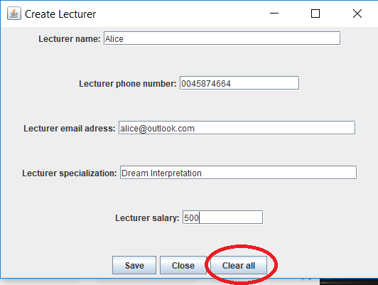

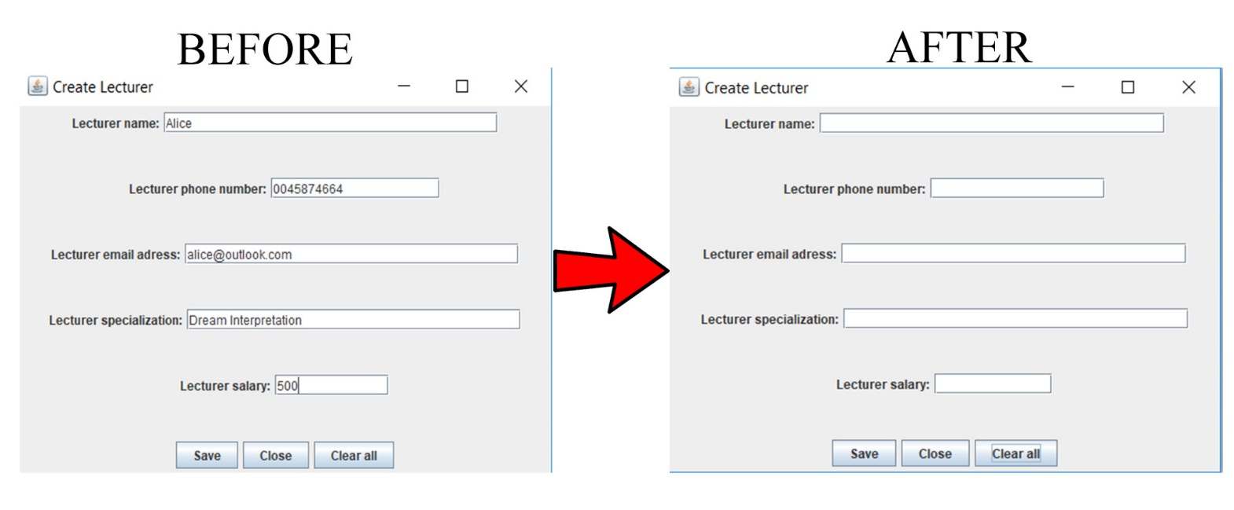

**Search Seminar**

To search for a Seminar, you will have to select the „Search Event” option from the main window.

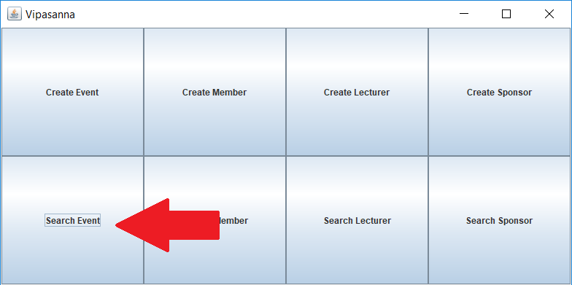

After that, click „Seminar”.

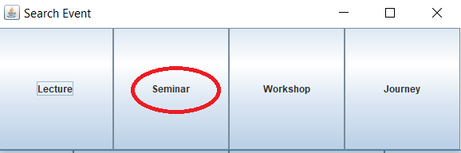

A new window will pop-up, for which you have multiple options:

1)View the current list of existing events on the left side on the window.

2)Filter the events, by either displaying all of them, or displaying Finalized/Non-finalized events.

3)Click the „Edit” button on the right side of the window to edit the informations for the currently selected seminar.

4)Click the „Delete” button on the right side of the window to delete the currently selected seminar.

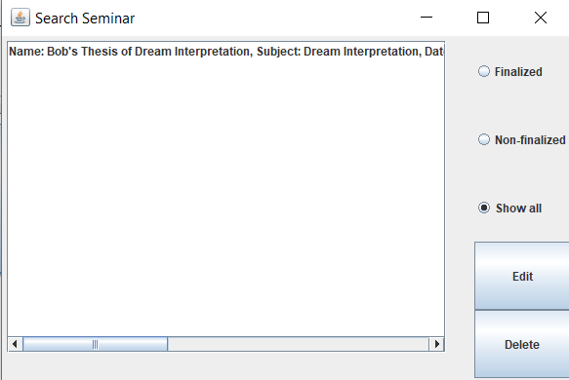

**Search Lecturer**

You first have to click the „Search Lecturer” button.

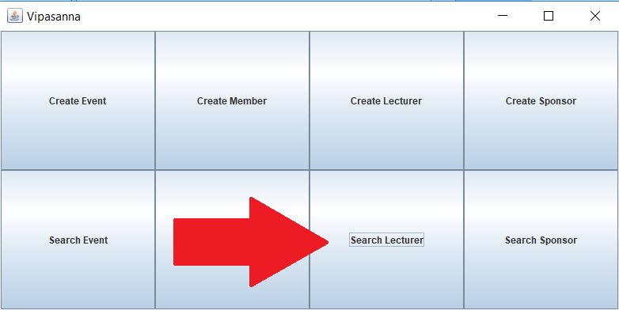

A new window will pop-up, for which you will have multiple options:

1)View the lecturers on the left side of the window.

2)Filter the lecturers by specialization.

3)Edit the data of the currently selected lecturer by clicking the „Edit” button on the right side of the window.

4)Delete the currently selected lecturer by clicking the „Delete” button on the right side of the window.

